|  |
| --- |
| CYBERSECURITY-LAB |
| SAAD USMAN |
| BCSP#243016 |

|  |
| --- |
| ztech  [Pick the date] |

**WEEK -12 (WIFI-HACKING)**

**Task 1:**

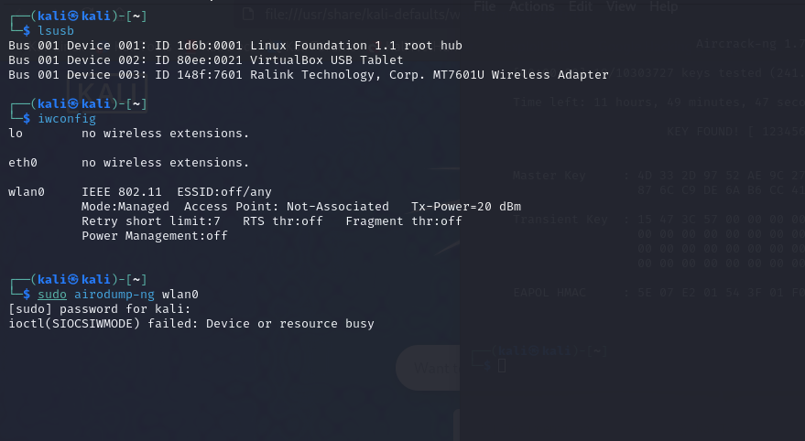

**Task 2:**

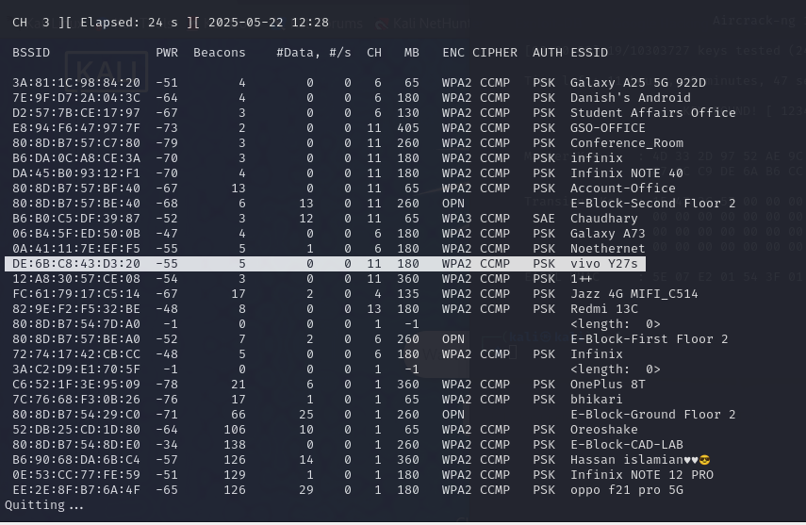

**Task 3:**



**Task 4:**

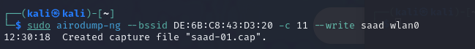

**Task 5:**

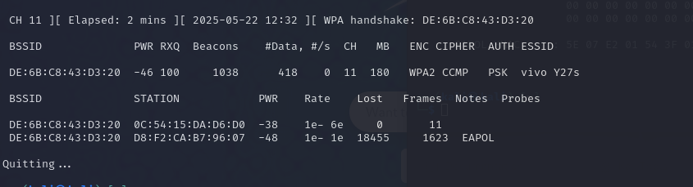

**Task 6: alag terminal pay likhna hai.**

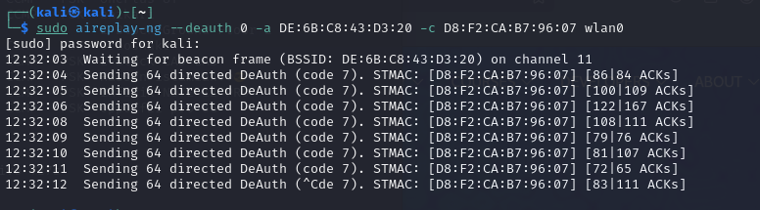

**Task 7:**

